Namibia University of Science and Technology

Faculty of Computing and Informatics
NUST Postgraduate Research Management Portal
Software Design & Development Documentation
System architecture, process design, database design and developer handover

Prepared by: David Mbidi
Student Number: 222017813
Supervisor: Dr. Simon Muchinenyika
Computer Science

Table of Contents
Table of Contents 2
1. Introduction 4
1.1 Purpose 4
1.2 Scope 4
1.3 Intended audience 4
1.4 Definitions and acronyms 4
2. System Overview 5
2.1 Background and problem statement 5
2.2 Objectives 5
2.3 High-level description 5
3. Development Methodology (SDLC) 5
4. Requirements 6
4.1 Functional requirements 6
4.2 Non-functional requirements 6
5. System Architecture 6
5.1 Technology stack 7
5.2 Request and data flow 7
6. Roles and Access Control 7
7. Process Design 9
7.1 Proposal submission and approval 11
7.2 Ethics application 13
7.3 Progress reports and semester tracking 13
7.4 Thesis submission 13
7.5 Examination and results 13
8. Mark Calculation Logic 15
9. Database Design 16
9.1 Key relationships 17
9.2 Data dictionary 19
10. Application Structure 20
10.1 Front end 20
10.2 Back end 20
10.3 API overview 20
11. User Interface 21
11.1 Sign-in and student 21
11.2 Supervisor 24
11.3 Coordinator 26
11.4 Faculty Representative and Examiner 31
11.5 Non-postgraduate view 33
12. Setup and Installation 33
12.1 Prerequisites 33
12.2 Steps 33
13. Configuration 34
14. Demonstration Accounts 34
15. Testing and Demonstration 35
16. Known Limitations and Future Work 35
17. Maintenance and Handover Notes 35

1. Introduction

1.1 Purpose
This document is the software design and development documentation for the NUST Postgraduate Research Management Portal. It explains, in depth, how the system is built and how every process works, so that the Faculty's software development team can understand, run, maintain and extend it. It also serves as the formal project documentation for academic review. The document covers the development approach, requirements, system architecture, role-based access, the complete set of business processes (with diagrams), the database design (with an entity-relationship diagram and data dictionary), the application structure, the user interface, setup and configuration, testing, and the remaining work.

1.2 Scope
The system manages the postgraduate research lifecycle within the Faculty of Computing and Informatics: research proposal submission and approval, ethics application, semester progress reporting, thesis submission, examination and marking, and the approval and release of final results. It is a working prototype that demonstrates the complete workflow end to end. Integration with the university's central systems (single sign-on and the student information system) is identified as future work in Section 16.

1.3 Intended audience
The primary audience is the Faculty software development team who will take over maintenance, and the academic supervisor evaluating the project. The reader is assumed to be comfortable with web development, JavaScript, REST APIs and relational databases.

1.4 Definitions and acronyms

Term | Meaning
SDLC | Software Development Life Cycle
SPA | Single-Page Application (the React front end)
API | Application Programming Interface (the Express back end)
JWT | JSON Web Token, used for authentication
HDC | Higher Degrees Committee
ER | Entity-Relationship (database diagram)
PK / FK | Primary Key / Foreign Key
ITS | The university's Integrated Tertiary Software (student records)
AD | Active Directory (university login directory)

2. System Overview

2.1 Background and problem statement
Postgraduate research at the faculty’s has been managed largely through email, paper forms and informal tracking. This makes it hard to see where a student is in the process, to keep proposal and examiner feedback together, to enforce the correct approvals, and to apply the examination marking rules consistently. The portal addresses this by moving the whole process into a single web application that guides each project through the correct steps and records every decision.

2.2 Objectives
- Provide one place to manage a research project from proposal to final result.
- Enforce the correct chain of authority and approvals at each stage.
- Keep proposals, evaluator feedback, theses, marks and comments together and visible to the right people only.
- Apply the examination marking rules consistently and flag cases that need human review.
- Give each role a clear, focused view of exactly what they need to do.

2.3 High-level description
Access follows a defined chain of authority — Super Admin, then Faculty HDC Representative, then Postgraduate Coordinator, then Supervisor, then Student. External examiners sit outside this chain and are brought in only to mark theses. Users who are not postgraduate students or academic staff receive a limited view of postgraduate news, announcements and upcoming presentations.

3. Development Methodology (SDLC)
The system was built using an iterative and incremental approach. Rather than building everything at once, the system was developed feature by feature, with each role and workflow implemented, tested, and then reviewed with the supervisor before moving on. Feedback from review sessions and from an interim presentation was fed back into the next iteration. This suited a project where the exact rules of the postgraduate process were clarified over time.
The phases of the life cycle were applied as follows:
- Requirements. The postgraduate process and the responsibilities of each role were established with the supervisor and refined after the interim presentations.
- Design. The architecture, the role-based access model, the process flows and the database schema were designed (Sections 5 to 9).
- Implementation. The front end and back end were built incrementally, one role and workflow at a time, with code committed at each milestone.
- Testing. Each feature was tested by walking through it as the relevant role using demonstration accounts (Section 15).
- Deployment. The system runs locally for demonstration; production deployment is covered as future work (Section 16).
- Maintenance. The code is organised so that features can be located and changed in one place; handover notes are in Section 17.

4. Requirements

4.1 Functional requirements
By role, the system must allow:
- Student: submit and resubmit a research proposal, complete the ethics application, submit progress reports, submit the thesis, and view their final result once released.
- Supervisor: review and approve or return proposals, comment on progress reports, act as internal examiner, and release approved marks to the student. Co-supervisors share visibility of their students' work.
- Postgraduate Coordinator: assign supervisors, assign at least two proposal evaluators, submit approved proposals to the Faculty Representative, assign examiners, compute and submit results, track registration per semester, schedule presentations, and view an overview of all students in the department.
- Faculty HDC Representative: record the HDC outcome for proposals and the HDC approval of final marks, with approvals recorded and visible at faculty level.
- External Examiner: mark an assigned thesis on a structured form and give a recommendation.
- Non-postgraduate user: view postgraduate news, announcements and upcoming presentations.

4.2 Non-functional requirements
- Security and access control: users authenticate with a token (JWT); each user only sees the screens and data appropriate to their role, and data is filtered by department.
- Confidentiality: evaluator feedback is visible to the supervisor and Coordinator only, and marks are not visible to the student until released.
- Usability: a clear, consistent interface with role-based navigation that scales to smaller screens.
- Maintainability: a modular structure with business rules (such as mark calculation) kept in dedicated functions.
- Data integrity: related records are linked by keys and statuses so the workflow cannot skip required steps.

5. System Architecture
The system uses a standard three-tier architecture. The browser runs a single-page React application that communicates with a Node.js and Express REST API over HTTP using JSON. The API applies the business rules and reads from and writes to a MySQL database through a connection pool. Authentication uses JSON Web Tokens: on login the API issues a signed token that the front end stores and sends with later requests. Uploaded files (proposal and thesis PDFs and signed consent forms) are stored on the server.
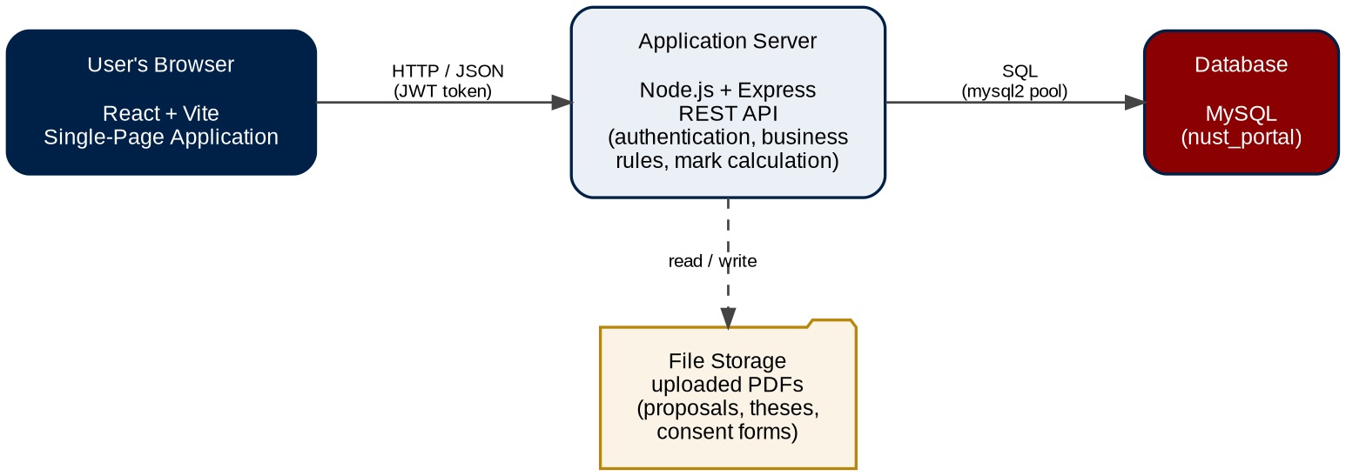
Figure 1: Three-tier system architecture.

5.1 Technology stack

Layer | Technologies
Front end | React, Vite, React Router DOM, JavaScript (ES6+), inline (CSS-in-JS) styling
Back end | Node.js, Express, mysql2 (connection pool), JSON Web Tokens, Multer (file uploads), CORS
Database | MySQL, administered with phpMyAdmin (run through XAMPP in development)
Tooling | npm, Git and GitHub, Visual Studio Code
The interface uses the university colours throughout — navy (#002147) and maroon (#8B0000) — for a consistent, branded appearance.

5.2 Request and data flow
- The user acts in the React interface; the app sends an HTTP request (with the JWT) to the API.
- The API verifies the token, applies the relevant business rules, and queries MySQL through the connection pool.
- The database returns the data; the API responds with JSON.
- The interface updates. Uploaded files are sent to the API and stored on the server, then served back on request.

6. Roles and Access Control
The system defines the roles below. Each user is routed to the screens for their role, and the API checks the token and filters data by department, so access is enforced on the server and not only hidden in the interface.
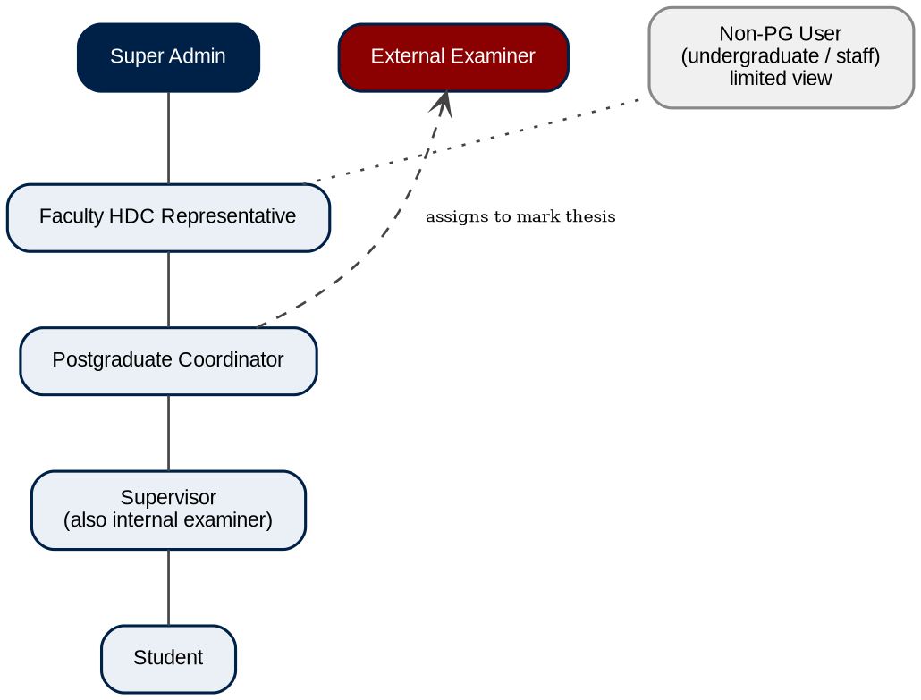
Figure 2: Role hierarchy and chain of authority.

Role | Key responsibilities
Super Admin | Top of the hierarchy; manages Faculty Representatives and Coordinators and oversees the system.
Faculty HDC Representative | Records the HDC outcome at faculty level; approvals are recorded and visible. Relays the committee's decision (approve or revisions) but does not unilaterally reject.
Postgraduate Coordinator | Assigns supervisors, evaluators and examiners; submits to the Faculty Representative; computes and submits results; tracks registration per semester; schedules presentations; and views a department-wide overview.
Supervisor | Reviews and approves proposals, comments on progress reports, acts as the internal examiner, and releases approved marks. Co-supervisors share visibility of their students.
External Examiner | Marks an assigned thesis on a structured evaluation form and gives a recommendation.
Student | Submits the proposal and thesis, completes the ethics application, submits progress reports, and views the final result once released.
Non-postgraduate user | Undergraduates and other staff receive a limited view of postgraduate news, announcements and upcoming presentations.

7. Process Design
This section describes every process in the system. Figure 3 shows the end-to-end lifecycle; the following sub-sections describe each stage in detail with its own flow.
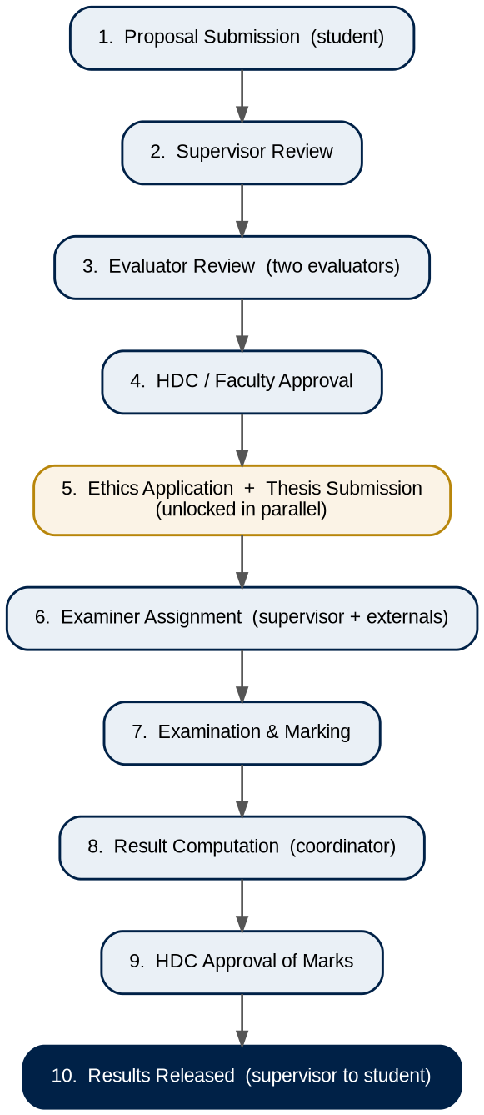
Figure 3: End-to-end postgraduate research lifecycle.

7.1 Proposal submission and approval
The proposal is the first and most involved process. The student submits it, the supervisor reviews it, the Coordinator assigns evaluators who endorse or request changes, and the Faculty Representative records the committee's outcome. Revision loops return the proposal to the student where changes are needed.
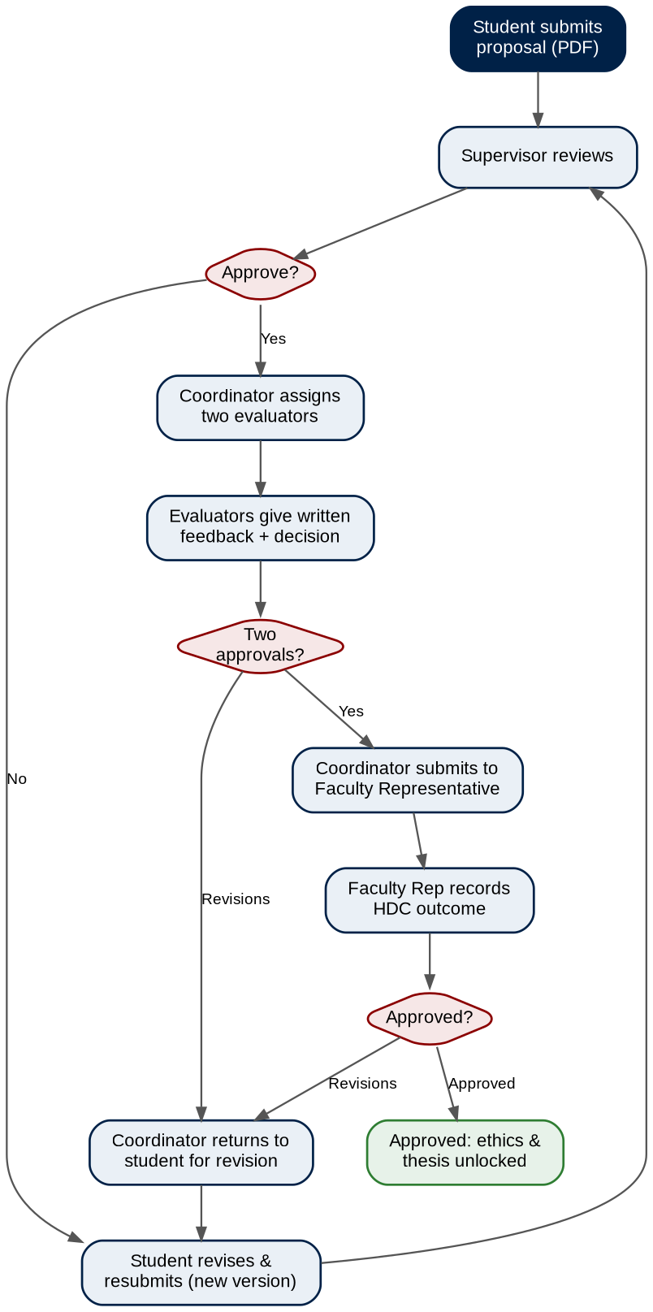
Figure 4: Proposal submission and approval workflow.
- The student submits a proposal (PDF) with a title and description; it is recorded as a versioned record.
- The supervisor (and co-supervisor) review it and either approve it or return it for revision. If returned, the student resubmits a new version and the history is kept.
- Once the supervisor approves, the Coordinator assigns at least two evaluators (other academic staff in the field). The Coordinator does not grade the proposal.
- Each evaluator gives written feedback and either approves or requests revisions. This feedback is visible to the supervisor and Coordinator, never to the student.
- If an evaluator requests revisions, the Coordinator returns the proposal to the student to revise and resubmit through the supervisor.
- Once at least two evaluators approve, the Coordinator submits the proposal to the Faculty Representative.
- The Faculty Representative records the HDC outcome. On approval, the ethics application and the thesis stage are unlocked; on revisions, it returns to the student.

7.2 Ethics application
After the proposal is approved, the student completes an in-system ethics application: whether the research involves human participants, the data-collection methods, the risks and how they will be mitigated, the informed-consent process, and how data will be protected, with an optional signed-consent upload. Ethics is handled at faculty level and is separate from the thesis; it does not block thesis submission.

7.3 Progress reports and semester tracking
The progress report is the only item with a fixed deadline — one per registered semester. The Coordinator records each student's registration per semester, and the system skips gap semesters, so a report is only expected for semesters in which the student is registered. The supervisor reviews and comments on each report. The student's dashboard and the supervisor's list show the current semester count based on registered semesters.

7.4 Thesis submission
Once the proposal is approved, the student submits the thesis. As with the proposal, it is reviewed by the supervisor and returned for revision where necessary before it proceeds to examination.

7.5 Examination and results
The Coordinator assigns examiners, the examiners mark the thesis, the Coordinator computes the result, the HDC approves it, and the supervisor releases it. Nothing is visible to the student until the whole chain is complete.
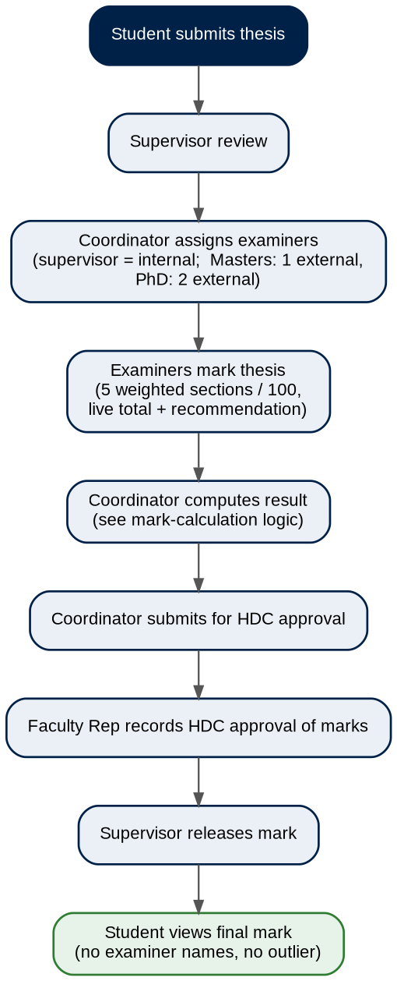
Figure 5: Examination and results workflow.
- The Coordinator assigns examiners. The supervisor is the internal examiner; a Master's thesis has one external examiner and a PhD thesis has two external examiners.
- Each examiner completes a structured evaluation form of five weighted sections totalling 100 marks, with a live running total, and records a recommendation (accept as is, accept after minor corrections, revise and resubmit, or do not award the degree).
- When all examiners have submitted, the marks and comments are sent to the Coordinator, who computes the result (Section 8).
- The Coordinator submits the result for HDC approval; the Faculty Representative records the approval; the supervisor releases the mark.
- The student sees only the final mark and recommendation — no individual examiner names and no excluded outlier.

8. Mark Calculation Logic
When all examiner marks are in, the Coordinator sees every mark, the reasons for each, and the final comments. The system then computes the result using the rules in Figure 6.
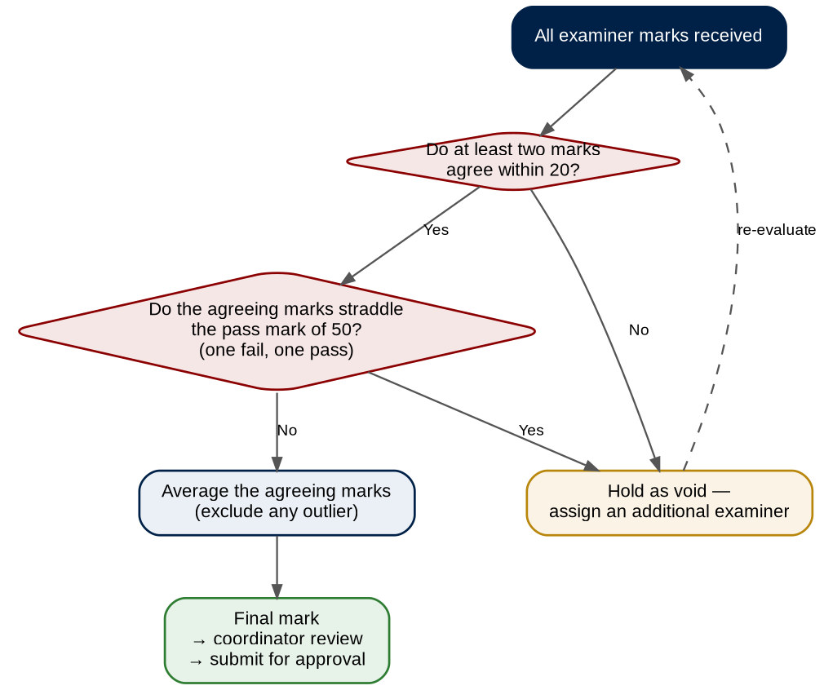
Figure 6: Mark-calculation decision logic.
- Marks that agree within 20 of each other are averaged.
- A mark that is more than 20 away from an agreeing group is treated as an outlier and excluded from the average.
- If no two marks agree within 20 of each other, the result is held as void and an additional examiner must be assigned.
- Pass/fail check: even when marks are within 20, if they fall on opposite sides of the pass mark (50) — one a fail and one a pass — an additional examiner is required, because the examiners disagree on the outcome.
Throughout, the Coordinator reviews the marks and comments before any result is finalised; for a PhD a faculty committee can be convened where the examiners disagree. Worked examples: marks of 76, 78 and 50 give a final of 77 (50 excluded as an outlier); marks of 50, 76 and 99 are held as void and a further examiner is assigned.

9. Database Design
The database is named nust_portal and has 16 tables, with foreign keys enforced under InnoDB. Figure 7 is the entity-relationship diagram; the data dictionary that follows lists each table with its key columns and purpose. The users table is the hub — most records link back to a user (as student, supervisor, evaluator or examiner).

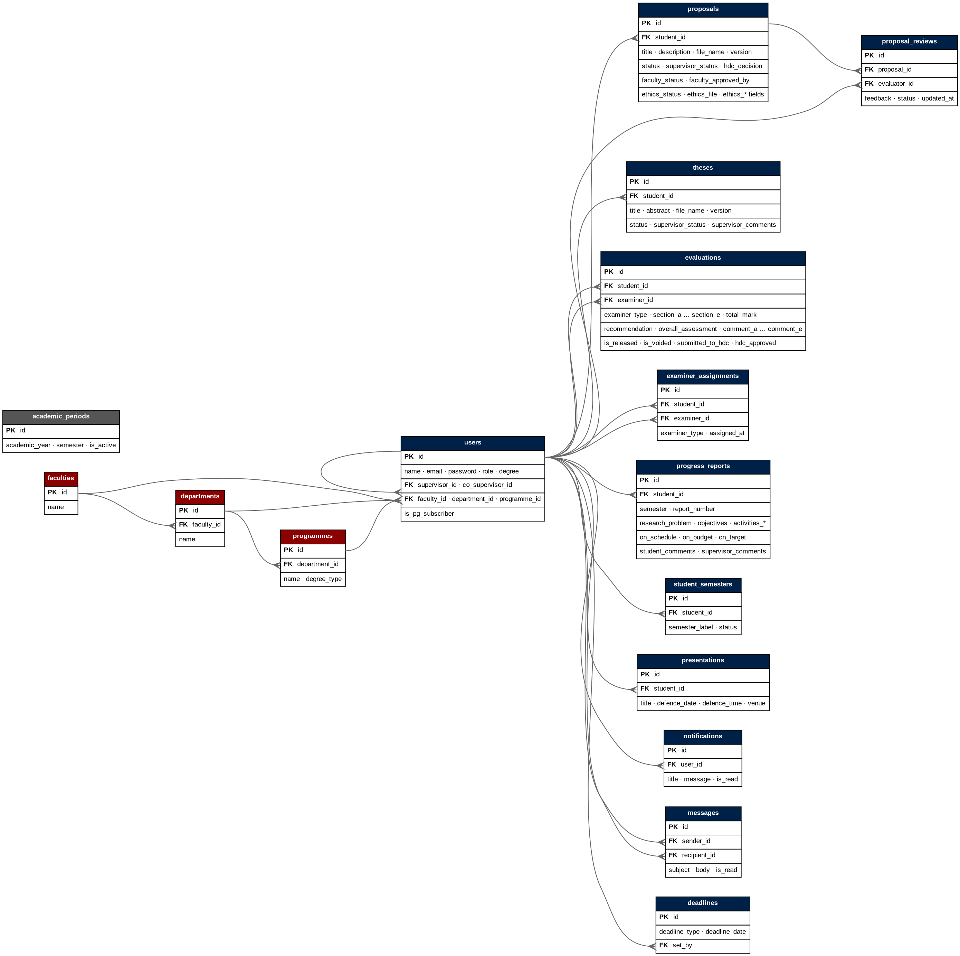
Figure 7: Entity-relationship diagram.

9.1 Key relationships
- A user can be a student, supervisor, evaluator or examiner; users.supervisor_id and co_supervisor_id link a student to their supervisor and co-supervisor (both reference users).
- Organisational structure: a faculty has many departments, a department has many programmes, and a user belongs to a faculty, a department and a programme (users.faculty_id, department_id, programme_id).
- A proposal belongs to a student (proposals.student_id) and has many evaluator reviews (proposal_reviews.proposal_id); proposals.faculty_approved_by records the user who entered the faculty decision.
- A thesis belongs to a student; evaluations and examiner_assignments each link a student to an examiner (both reference users).
- progress_reports, student_semesters, presentations and notifications each belong to a user; messages link a sender and a recipient; deadlines.set_by references the user who set the deadline.
- Foreign keys are enforced in the database (InnoDB), and the users table is the hub that most records reference.

9.2 Data dictionary

Table | Key columns | Purpose
users | id (PK); name, email, password, role, degree; supervisor_id, co_supervisor_id (FK to users); faculty_id, department_id, programme_id (FK); is_pg_subscriber | All accounts, their role, and academic links.
faculties | id (PK); name | Faculties.
departments | id (PK); faculty_id (FK); name | Departments within a faculty.
programmes | id (PK); department_id (FK); name, degree_type | Postgraduate programmes within a department.
proposals | id (PK); student_id (FK); title, description, file_name, version; status, supervisor_status, supervisor_comments; hdc_decision, hdc_comments; faculty_status, faculty_approved_by, faculty_comments; ethics_status, ethics_file, ethics_involves_humans, ethics_data_methods, ethics_risks, ethics_consent_process, ethics_data_protection | Research proposals and their progress through review, approval and the ethics application.
proposal_reviews | id (PK); proposal_id (FK); evaluator_id (FK); feedback, status; created_at, updated_at | Evaluator feedback and approval per proposal.
theses | id (PK); student_id (FK); title, abstract, file_name, version; status, supervisor_status, supervisor_comments | Submitted theses and their supervisor review.
evaluations | id (PK); student_id (FK); examiner_id (FK); examiner_type; section_a..section_e, total_mark; recommendation, overall_assessment, comment_a..comment_e; is_released, released_at, is_voided, voided_reason, submitted_to_hdc, hdc_approved | Examiner marks, comments, recommendation, and release / HDC state.
examiner_assignments | id (PK); student_id (FK); examiner_id (FK); examiner_type; assigned_at | Which examiners are assigned to a thesis.
progress_reports | id (PK); student_id (FK); semester, report_number; research_problem, objectives, activities_completed / in_progress / outstanding; on_schedule, on_budget, on_target; adjustments, challenges, risks; student_comments, supervisor_comments | Per-semester progress reports and supervisor comments.
student_semesters | id (PK); student_id (FK); semester_label, status | Per-student registration for semester tracking.
presentations | id (PK); student_id (FK); title, defence_date, defence_time, venue | Scheduled defences shown on the home page.
notifications | id (PK); user_id (FK); title, message, is_read | In-app notifications raised by the workflow.
messages | id (PK); sender_id (FK), recipient_id (FK); subject, body, is_read | Staff-to-staff messaging.
deadlines | id (PK); deadline_type, deadline_date; set_by (FK to users) | Progress-report deadlines.
academic_periods | id (PK); academic_year, semester, is_active | The current academic period.
The tables and columns above reflect the live database schema (16 tables, with foreign keys enforced under InnoDB).

10. Application Structure

10.1 Front end
- src/pages — screens grouped by role (student, supervisor, coordinator, faculty rep, examiner, admin) and shared pages.
- src/components — reusable pieces such as the navigation bar and loading indicator.
- src/context — authentication context that stores the logged-in user and protects routes.

10.2 Back end
- routes — Express route modules (proposals, evaluations, auth, uploads, and supporting modules).
- db — the MySQL connection pool used by the routes.
- uploads — the directory where uploaded PDF files are stored.

10.3 API overview

Module | Representative endpoints and purpose
Authentication | Login and account lookup; issues the JWT used to authorise later requests.
Proposals | Submit, list, supervisor review, assign evaluators, submit evaluator feedback, submit to faculty, record HDC outcome, return for revision, resubmit version, ethics application.
Evaluations | Submit examiner marks, list by examiner / student / department, compute and submit results for HDC approval, record HDC approval, release results.
Assignments | Assign examiners to a thesis and list a given examiner's assigned theses.
Uploads | Receive and serve PDF files (proposals, theses, consent forms).
Supporting | Supervisors, semesters, deadlines, periods, presentations, messages and notifications.

11. User Interface
This section shows the main screens of the system

11.1 Sign-in and student
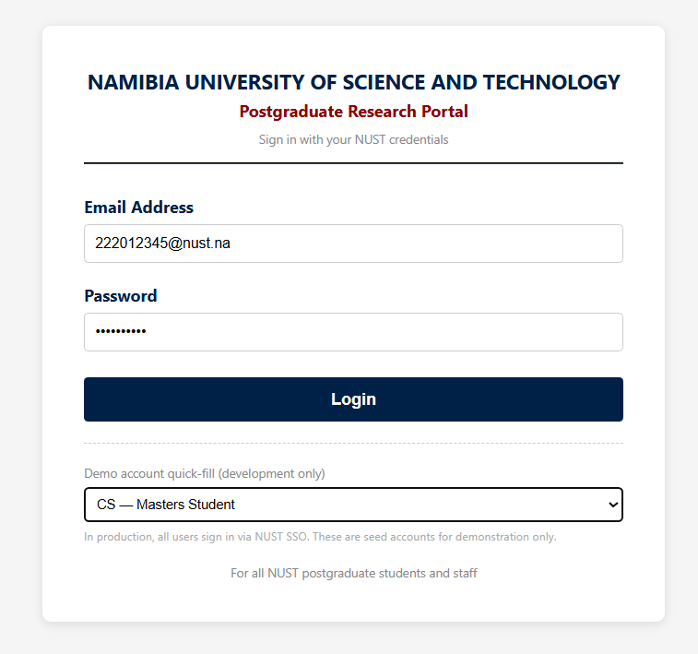
Sign-in screen.

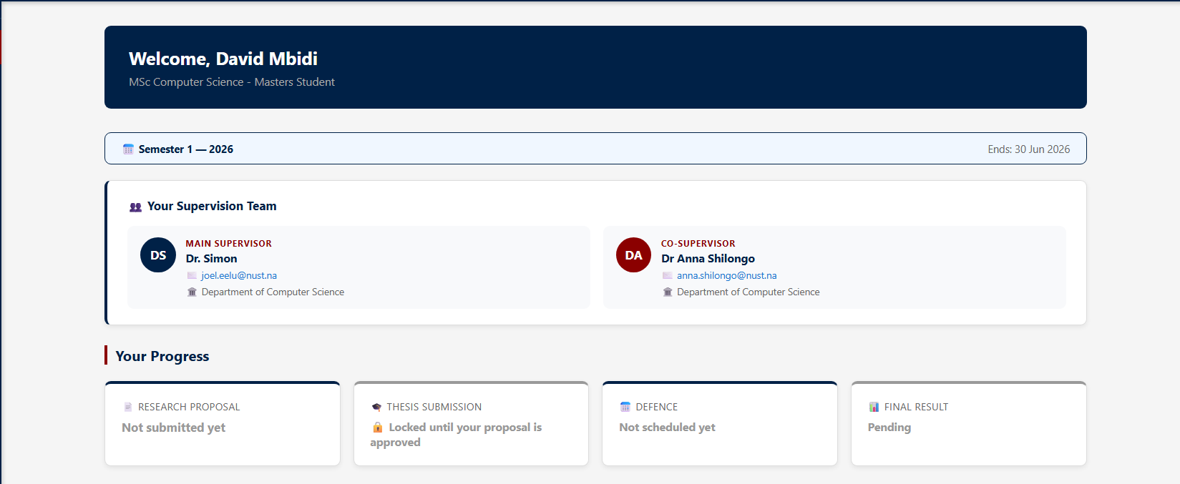Student dashboard.

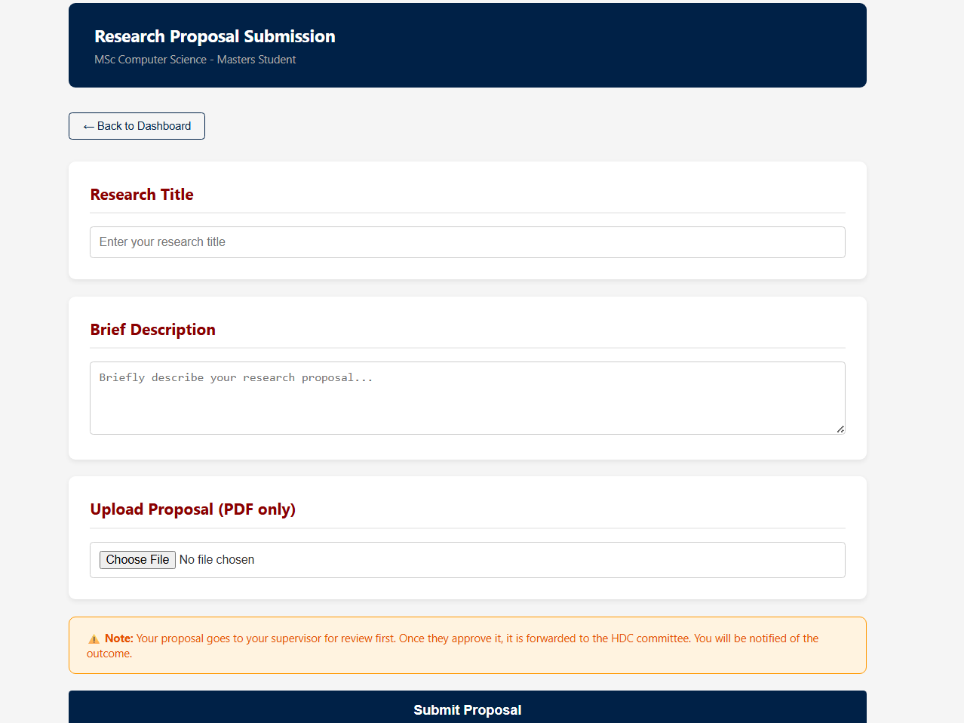Proposal submission page (title, description, PDF upload).

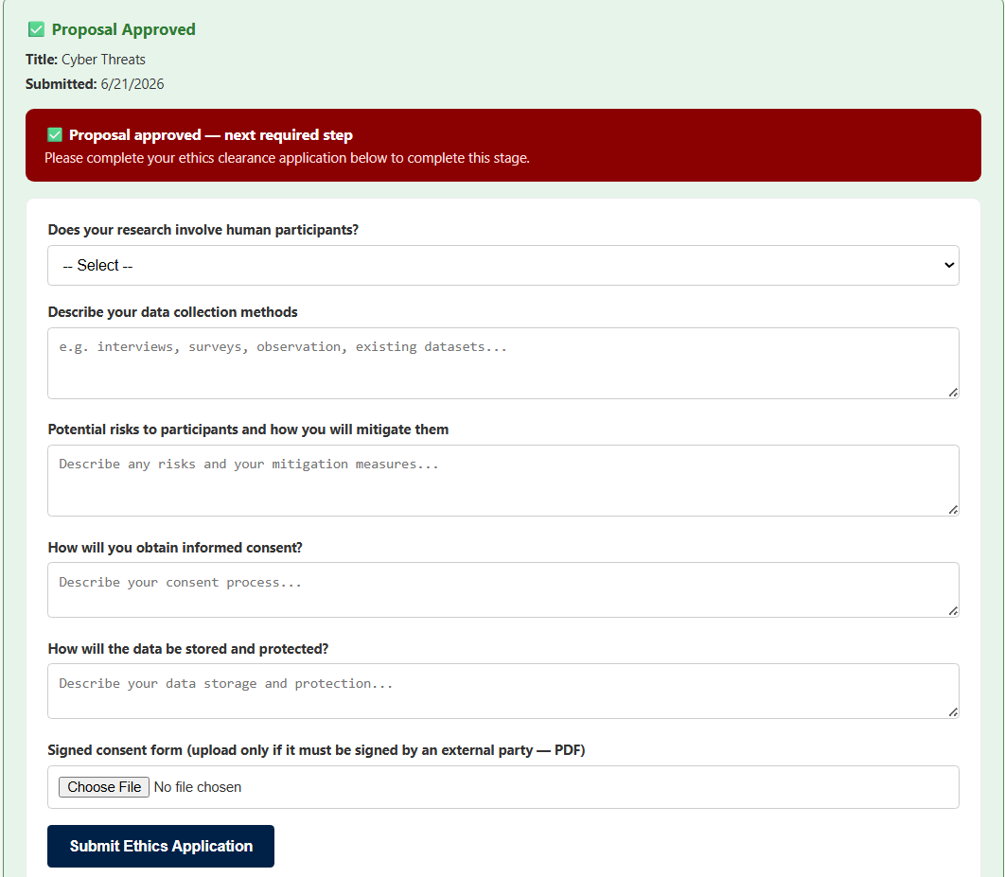Ethics application form.

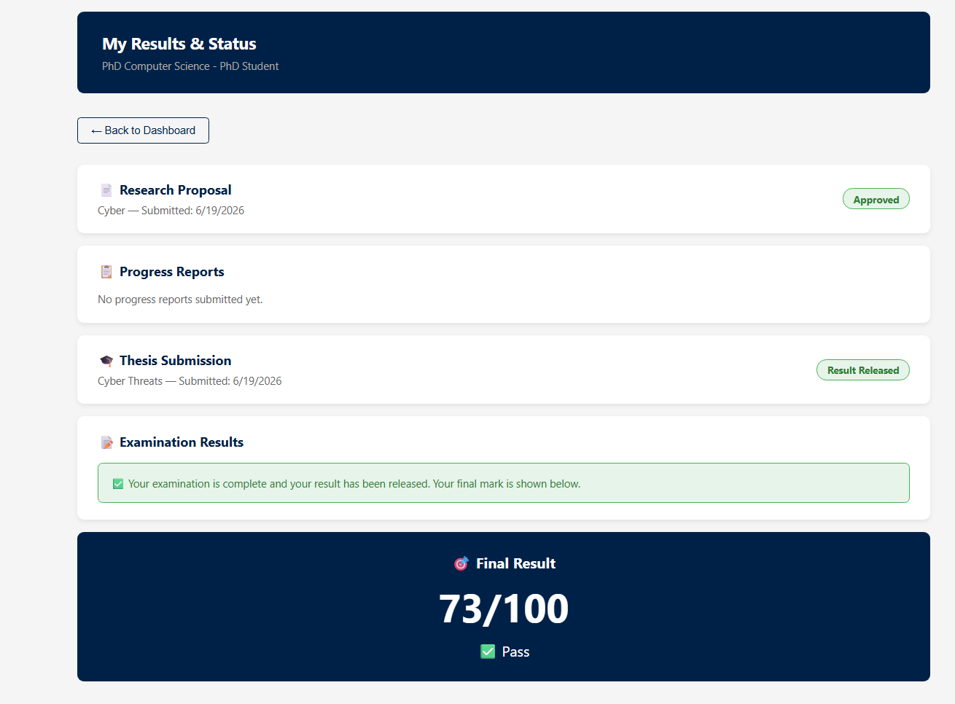Student final result view (after release).

11.2 Supervisor
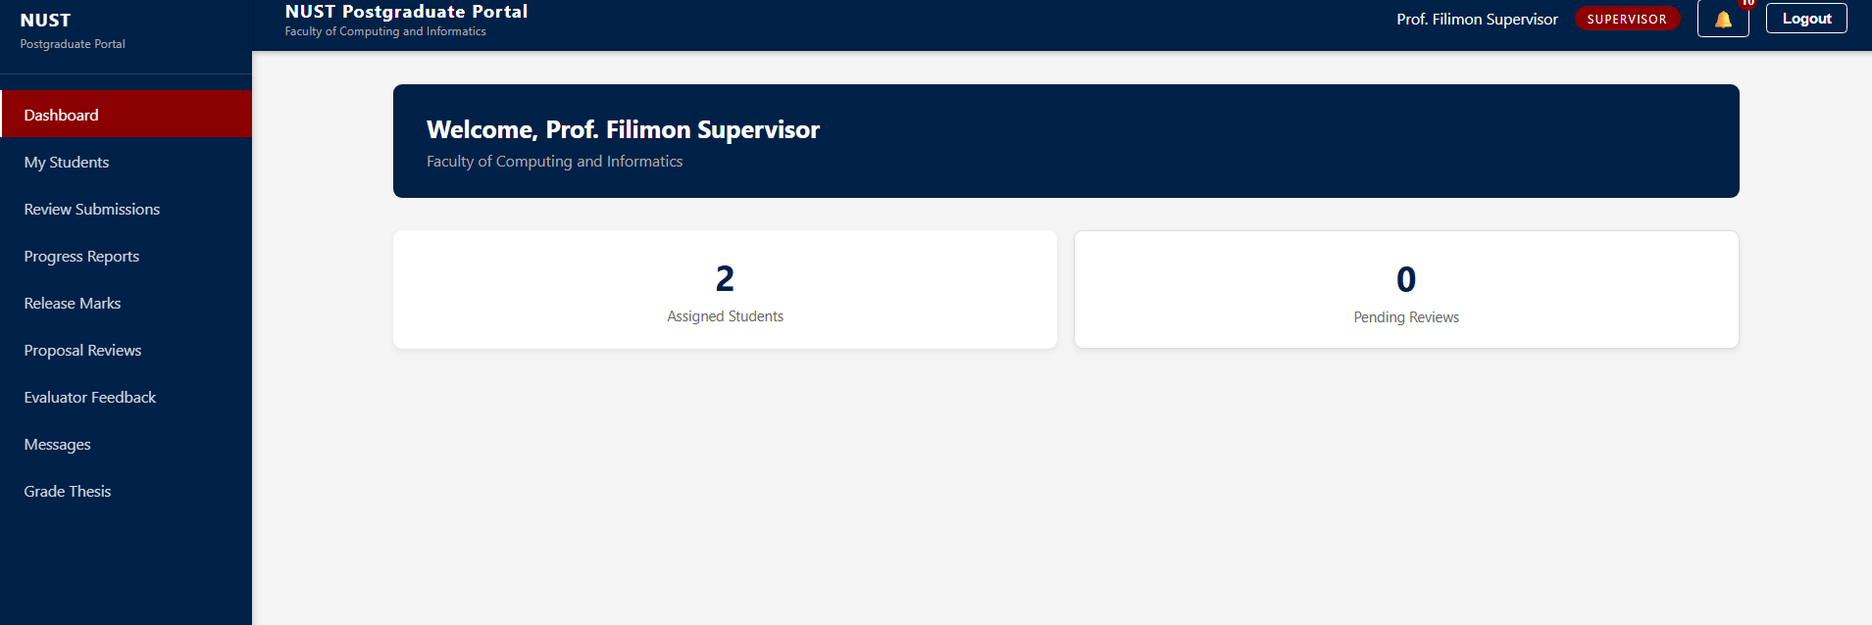Supervisor dashboard.

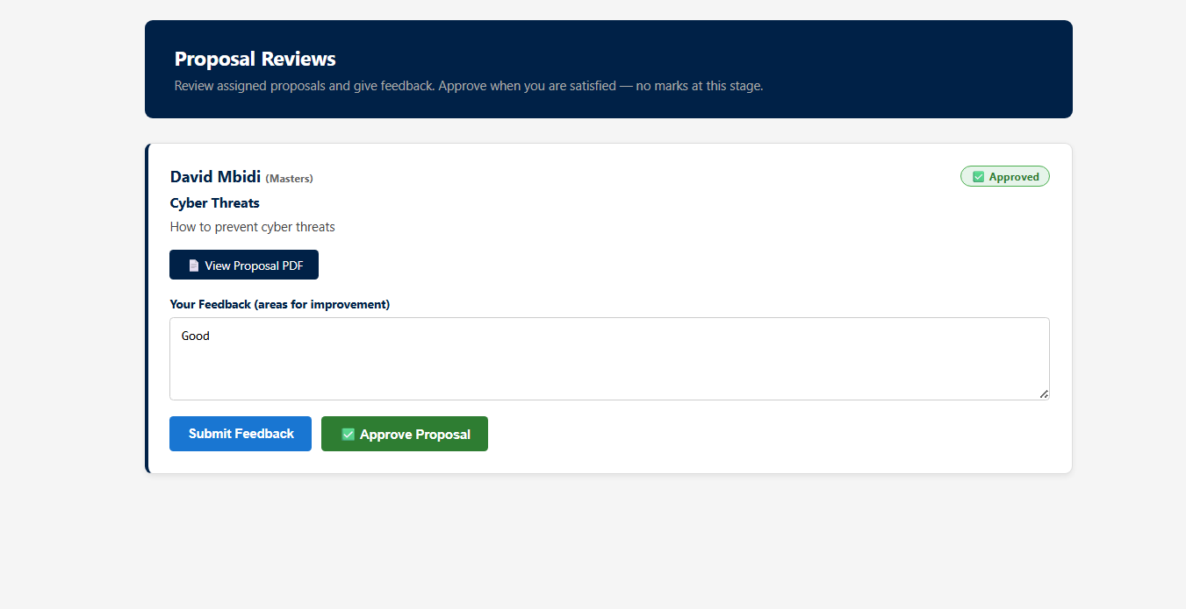Proposal review (approve / return for revision).

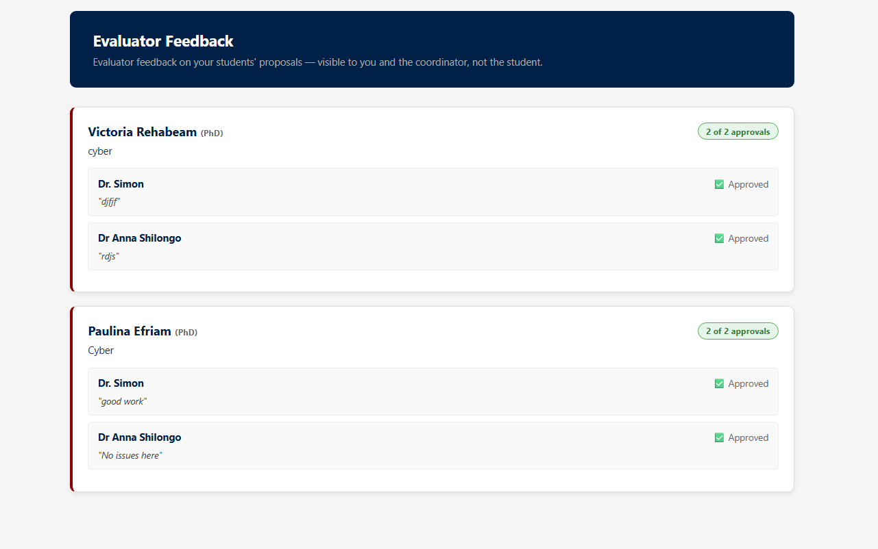Evaluator feedback view (supervisor sees evaluator comments).

11.3 Coordinator
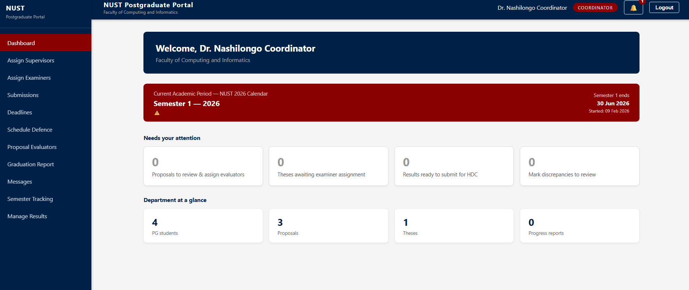Coordinator dashboard / department overview.

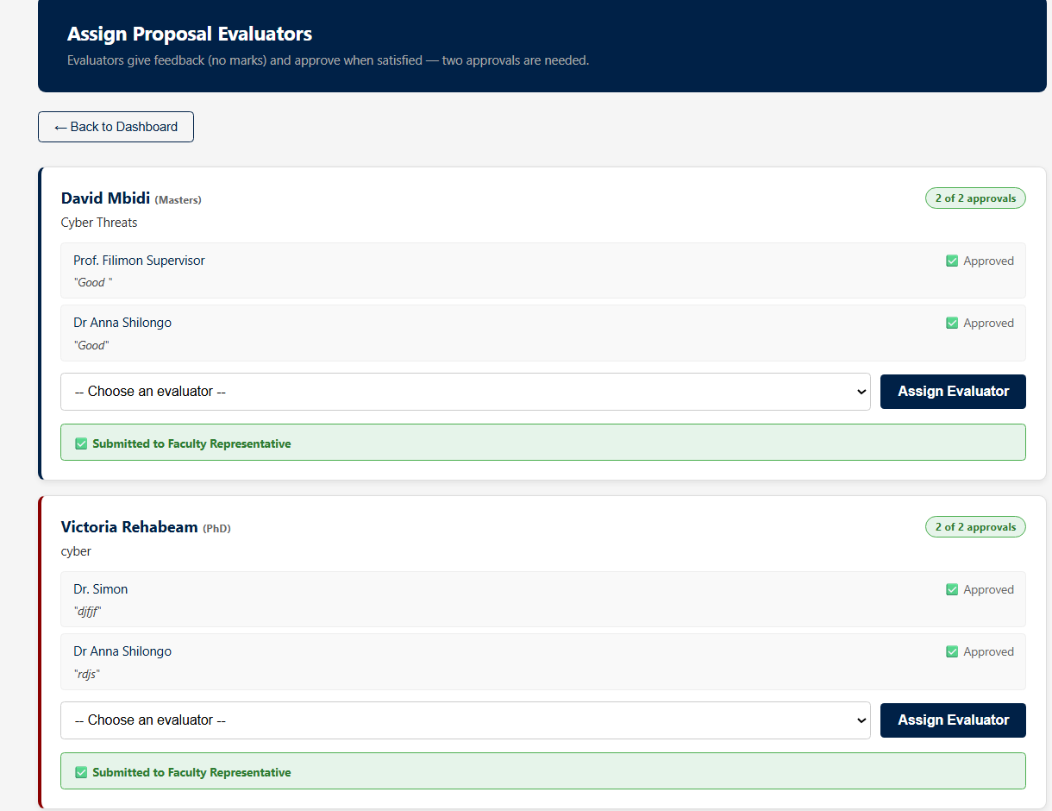Assign proposal evaluators.

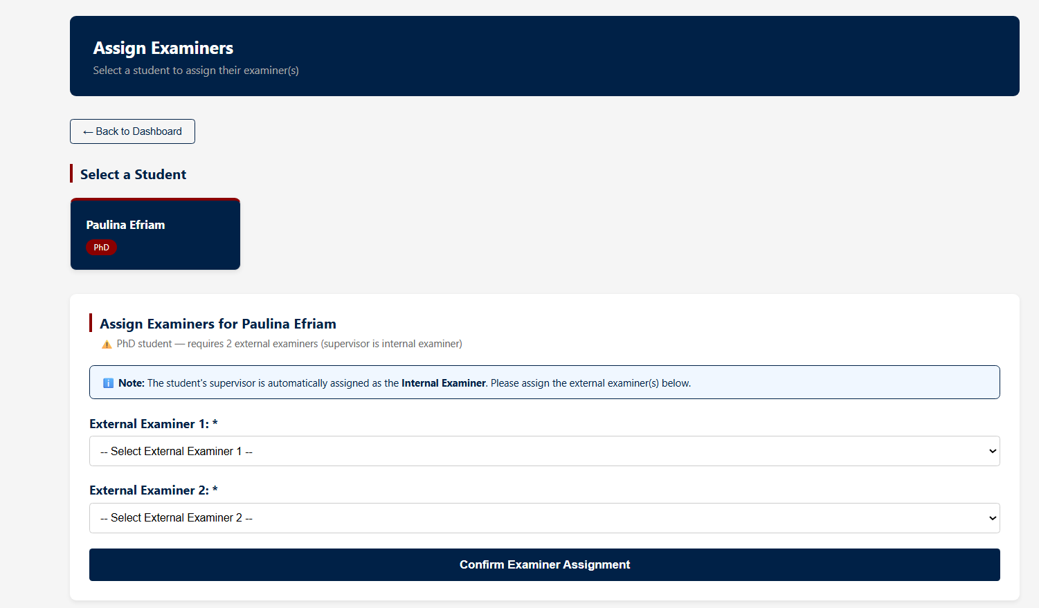Assign examiners.

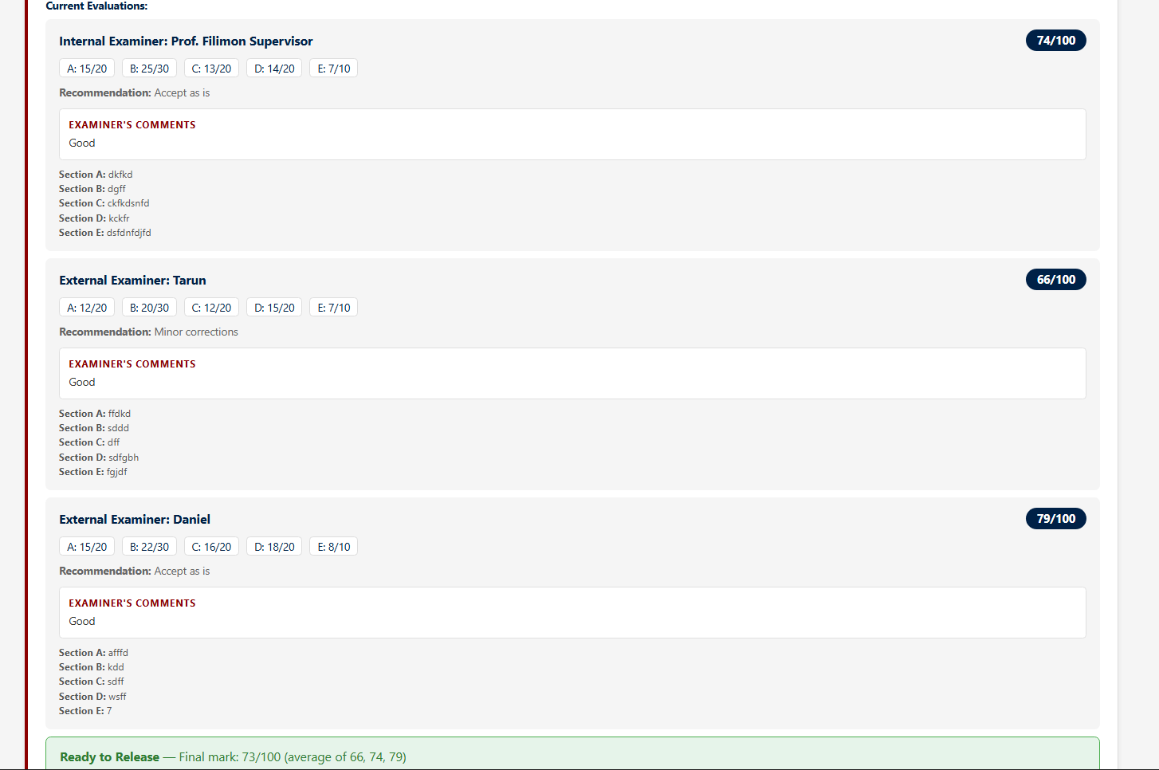Manage results (marks, discrepancy handling, submit for approval).

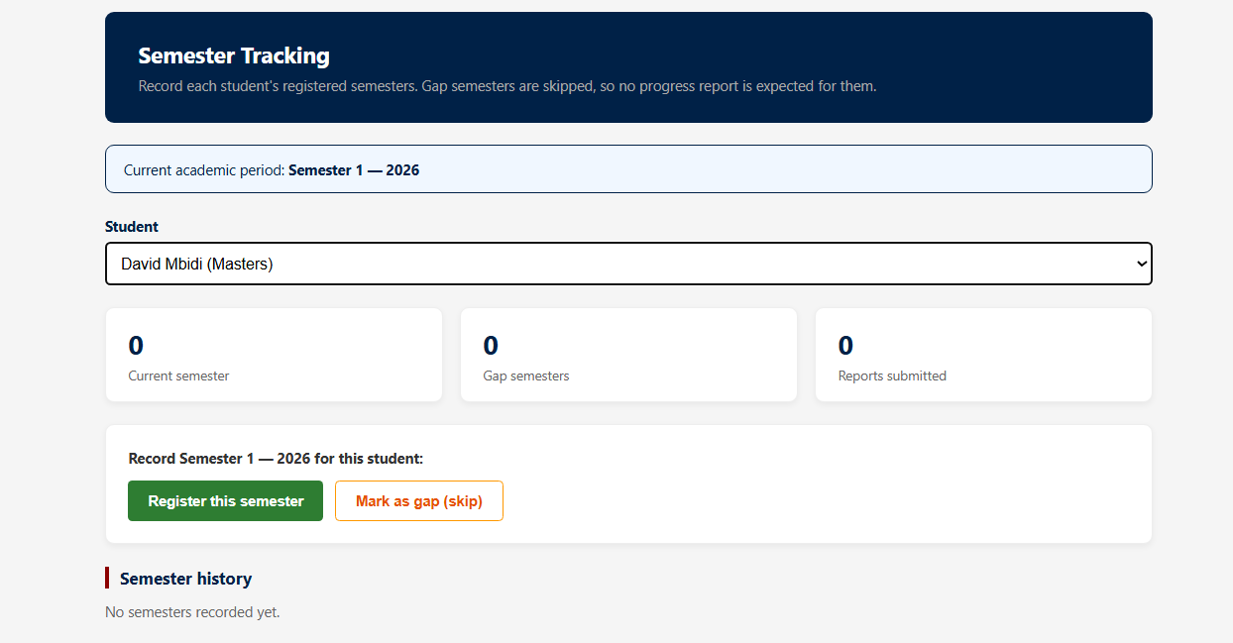Semester tracking.

11.4 Faculty Representative and Examiner
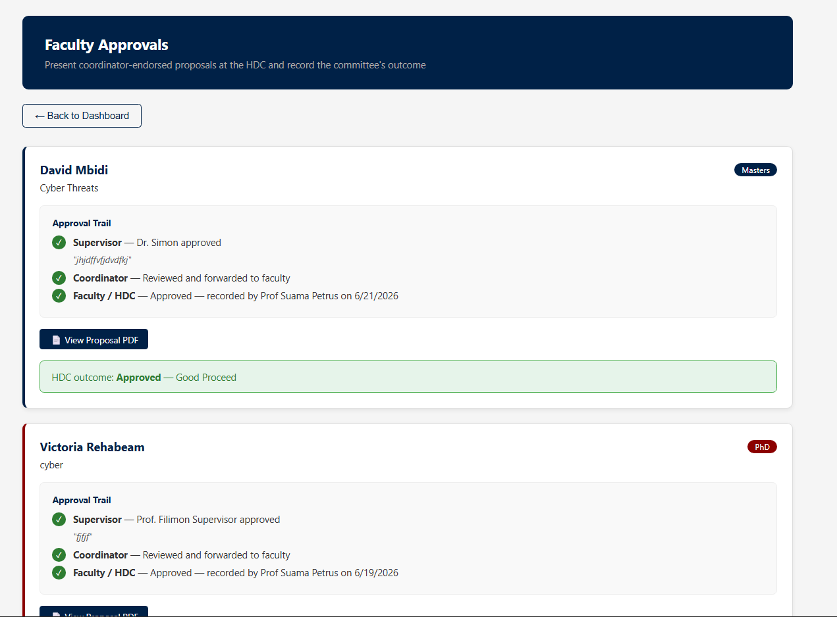Faculty Representative — record HDC outcome / approvals.

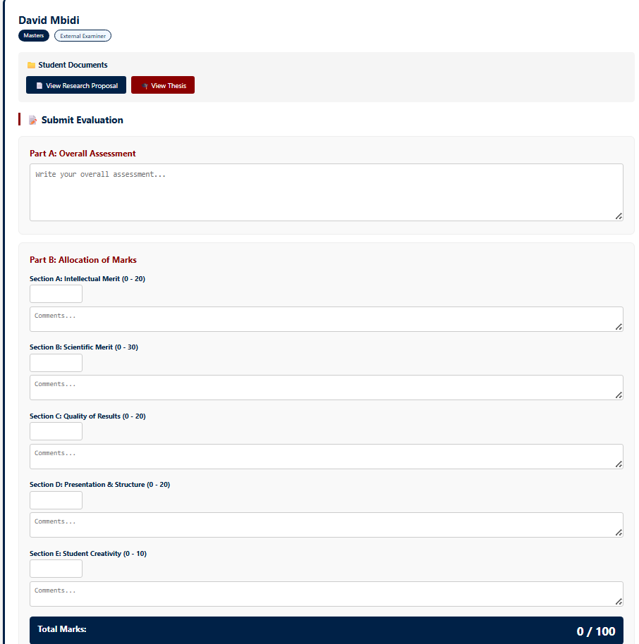Examiner evaluation form (five sections with live total).

11.5 Non-postgraduate view
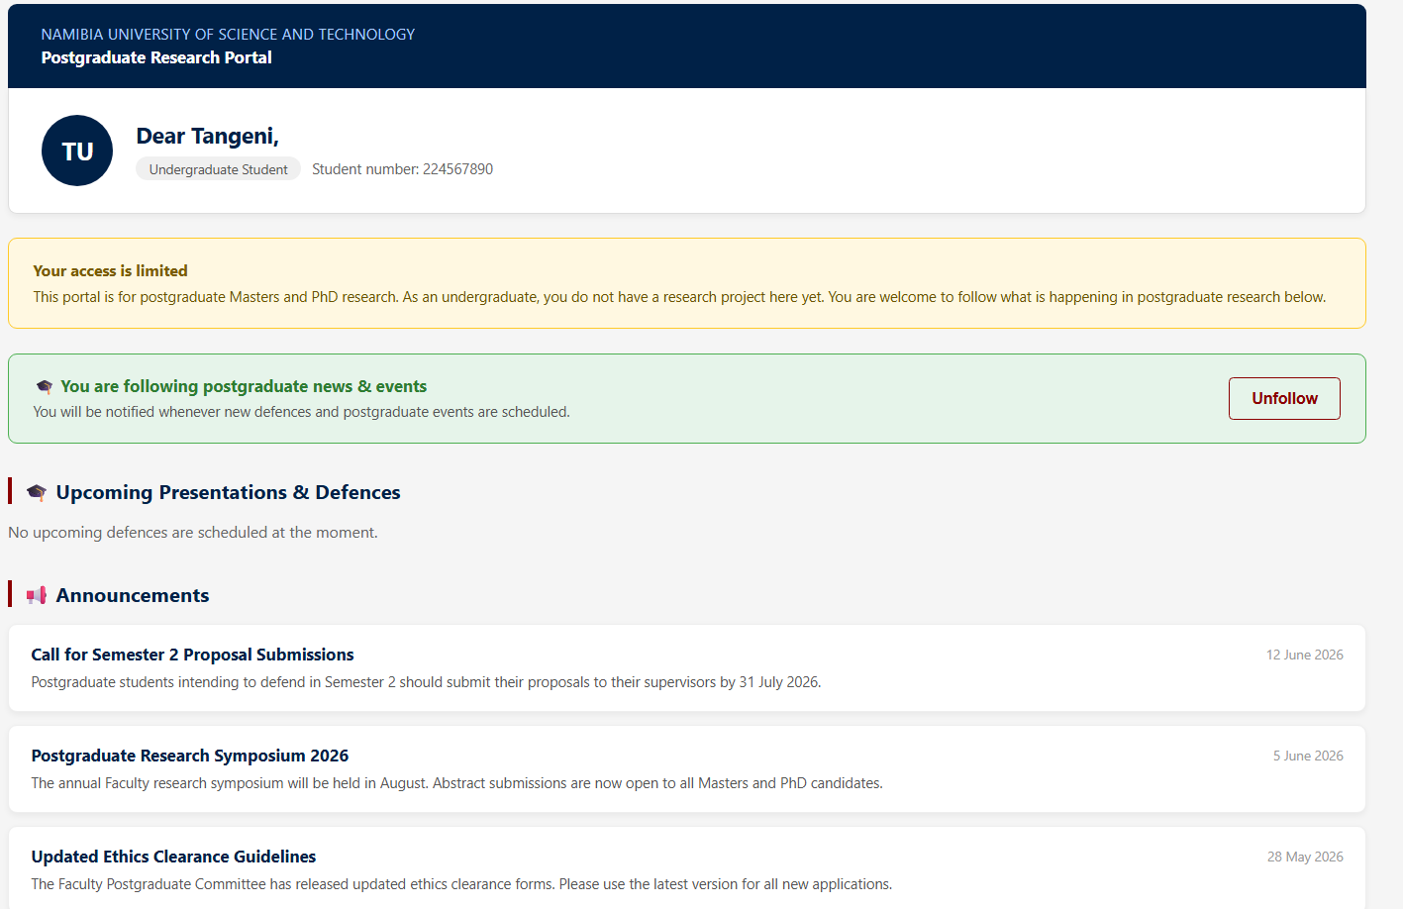Limited landing page (news, announcements, upcoming presentations).

12. Setup and Installation

12.1 Prerequisites
- Node.js and npm.
- XAMPP (or any MySQL server) with phpMyAdmin.
- Git.

12.2 Steps
- Clone the repository from GitHub.
- Start MySQL in XAMPP and open phpMyAdmin.
- Create a database named nust_portal and import the provided schema (and seed data, if supplied).
- Confirm the database connection settings in the back-end database configuration match your local MySQL (host, user, password, database).
- Install front-end dependencies (npm install) in the project root.
- Install back-end dependencies (npm install) in the backend folder.
- Start the back end (npm run dev) — it runs on port 5000.
- Start the front end (npm run dev) — it runs on port 5173.
- Open the front-end URL in a browser and sign in with one of the demonstration accounts in Section 14.

13. Configuration
- Database connection (host, user, password, database) is set in the back-end database configuration.
- The back end runs on port 5000 and the front end on port 5173; the front end calls the API at http://localhost:5000.
- Authentication tokens (JWT) are valid for 8 hours.
- Uploaded files are stored in the back-end uploads directory.

14. Demonstration Accounts
The following accounts are provided for testing each role. They use plaintext passwords for demonstration only and must be removed or secured before any production use (Section 16).

Role | Email | Password
Super Admin | superadmin@nust.na | super123
Faculty HDC Representative | faculty.rep@nust.na | rep123
Coordinator (Computer Science) | coordinator@nust.na | coord123
Coordinator (Civil) | civil.coordinator@nust.na | coord123
Supervisor / internal examiner | simon.muchinenyika@nust.na | supervisor123
Supervisor / evaluator | fili.nghidengwa@nust.na | supervisor123
Supervisor / evaluator | anna.shilongo@nust.na | supervisor123
External examiner | examiner@nust.na | examiner123
External examiner | examiner2@nust.na | examiner123
External examiner | examiner3@nust.na | examiner123
Master's student | 222012345@nust.na | student123
PhD student | 221098765@nust.na | phd123
PhD student (Civil) | 223009988@nust.na | student123
Undergraduate (limited view) | 224567890@nust.na | demo123
Junior lecturer (limited view) | john.junior@nust.na | demo123

15. Testing and Demonstration
The system was tested manually by walking through each workflow as the relevant role using the demonstration accounts. A full end-to-end test covers: signing in across the role hierarchy; assigning a supervisor; submitting a proposal and approving it through the supervisor, the two evaluators and the Faculty Representative; completing the ethics application and a progress report; submitting the thesis; assigning examiners; entering marks; computing the result; approving and releasing it; and finally viewing it as the student.
The mark-calculation rules were tested with specific cases, for example: marks of 76, 78 and 50 produce a final of 77 with 50 excluded as an outlier; marks of 50, 76 and 99 are held as void and an additional examiner is required; and two marks that straddle the pass mark (such as 48 and 60) require an additional examiner even though they are within 20.

16. Known Limitations and Future Work
The system is a working prototype that demonstrates the complete workflow. The following are recommended for production and for future development:
- Single sign-on. In production the system should authenticate against the university's Active Directory (NUST credentials) with no separate registration, rather than maintaining its own accounts.
- Results via ITS. In the live environment students obtain final marks through ITS in the normal way. The supervisor-release step here models that flow for demonstration; production should integrate with ITS as the system of record for marks.
- Research clearance process. Some research requires external clearance (a faculty letter taken to the relevant body, for example the Ministry of Education or Ministry of Health), while other research does not. This external clearance process is not yet modelled in the system and is recommended as a future addition, to be confirmed with the supervisor.
- Password security. Demonstration passwords are stored in plain text; production must store hashed passwords or rely entirely on single sign-on.
- Notifications. The system uses in-app notifications; email or SMS notifications could be added alongside them.
- Automated testing and reporting. An automated test suite and expanded reporting and analytics would improve maintainability and oversight.

17. Maintenance and Handover Notes
- Business rules such as the mark-calculation logic are kept in dedicated functions so they can be reviewed and adjusted in one place.
- New screens are added under the relevant role folder in src/pages and wired into the router; new server features are added as a route module and registered with the API.
- Source code is provided through the project's GitHub repository; maintenance can be transferred to the Faculty development team by adding them as collaborators or transferring repository ownership.
- Before production use, replace the demonstration accounts, secure the database credentials and the JWT secret, and complete the items in Section 16.

End.

